LAB Logbook

Lab 1

1. a=np.arange(43)

print (a)

1. a=a.reshape(1,43)

print(a)

1. b=a

print(b)

1. print(b.shape)

The result of the following code :

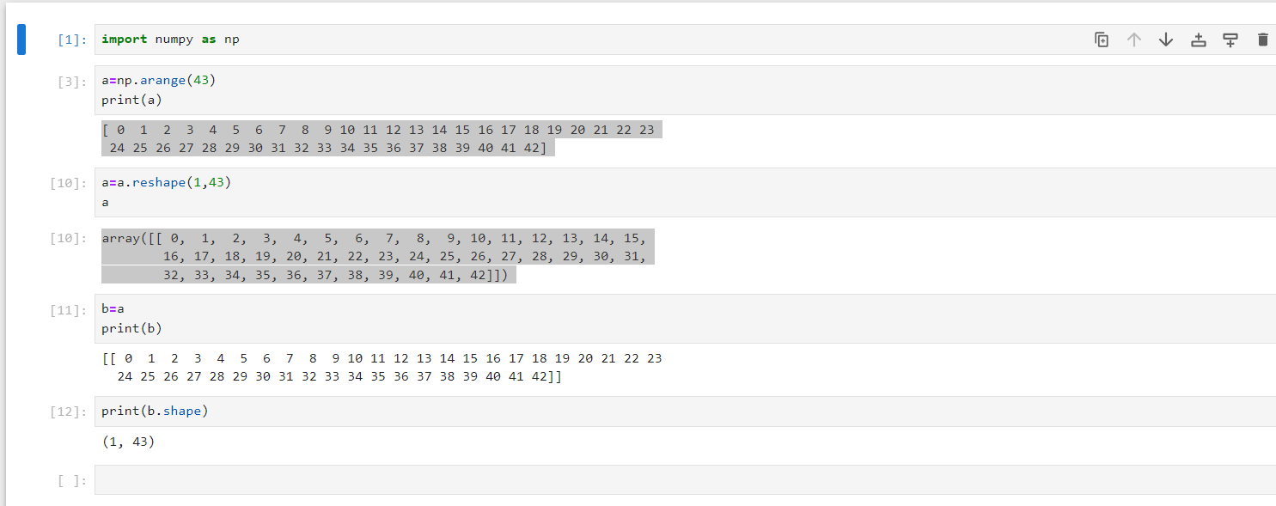

Lab 2

Lab 3

Lab 4

Lab 5

Lab 6

Lab 7

Lab 8

Lab 9

Lab 10

Lab 11

Lab 12